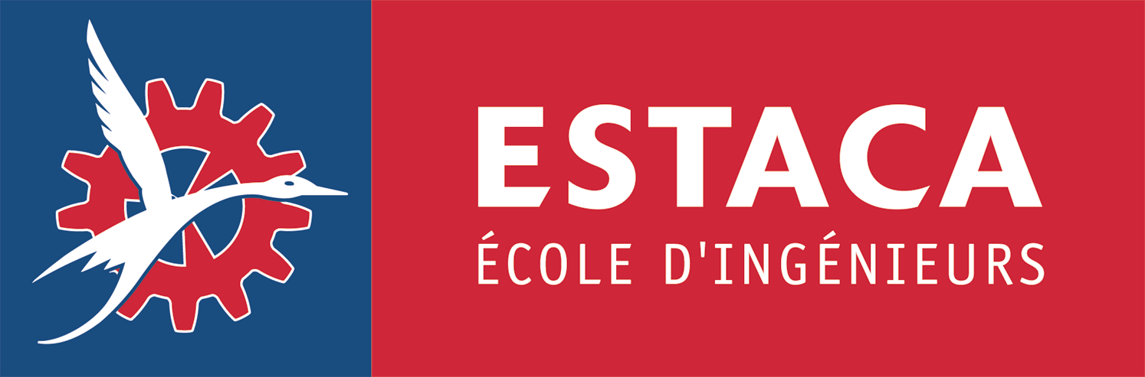 INTERNATIONAL PROGRAM :
COMPUTER AIDED ENGINEERING AND DESIGN

APPLICATION PROCEDURE

Application materials :
- Application form part I and part II (enclosed)
- Official university transcipts
- CV/ resume
- A confidential recommendation from a professor acquainted with your academic qualifications (form enclosed)
- Statement of intention to apply for ESTACA International Program (explain your motivations)
- TOEFL/ TOEIC/ Cambridge Certificate transcript (if English is not your native language)
- Passport/ I.D. copy

The above application materials should be sent or faxed to :
ESTACA
Farida Chabouni-Gabard
International Exchange Programs Coordinator
34-36 rue Victor Hugo
92300 Levallois-Perret, France
Fax : 00 33 1 41 27 60 25

Application deadline : November 30th, 2005
For late application, please contact F. Chabouni-Gabard (fchabouni@estaca.fr)

